Azure Data Engineer

DIFFRENT CLOUD PROVIDER
- Azure
- AWS
- GCP

TYPES OF CLOUD:-
- Public
- Private
- Hybrid
AZURE DATA Skills :-
- ADLS
- ADF
- Python
- Data Bricks
- Azure Synapse
- Tableau/Power BI

ADLS: --

🔍 What is ADLS?
Azure Data Lake Storage (ADLS) is a cloud-based storage service optimized for analytics workloads. It allows you to store massive amounts of structured and unstructured data and is tightly integrated with the Azure ecosystem.

🧱 Key Features

Hierarchical namespace: Like a file system, supports directories and files.
Scalable: Handles petabytes of data.
Secure: Integrated with Azure Active Directory (AAD), role-based access control (RBAC), and encryption.
Cost-effective: Pay-as-you-go model.
Supports Hadoop: Compatible with HDFS, so tools like Databricks, HDInsight, and Azure Synapse can read/write directly.

🧰 Common Use Cases

Storing raw data for analytics pipelines
Data ingestion from various sources (IoT, logs, databases)
Machine learning and AI workloads
Integration with tools like Azure Data Factory, Databricks, Synapse Analytics

🆚 ADLS Gen1 vs Gen2

Gen1: Older, limited to hierarchical namespace, not recommended for new projects.
Gen2: Combines Blob Storage features with hierarchical namespace, better performance, and lower cost.

🧰 Example Pipeline Flow
Source (SQL/CSV/API) → Azure Data Factory → ADLS Gen2 → Databricks/Synapse → Power BI

Data Engineer Architecture:-
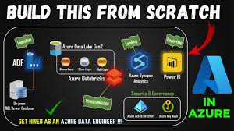

Azure Storage Account: -types
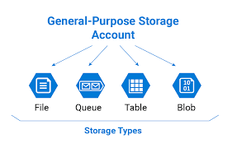

Types of Service Models: -
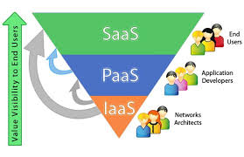

Project: -
https://github.com/Nikhil-Pickle/End-to-End-Azure-Data-Engineering

